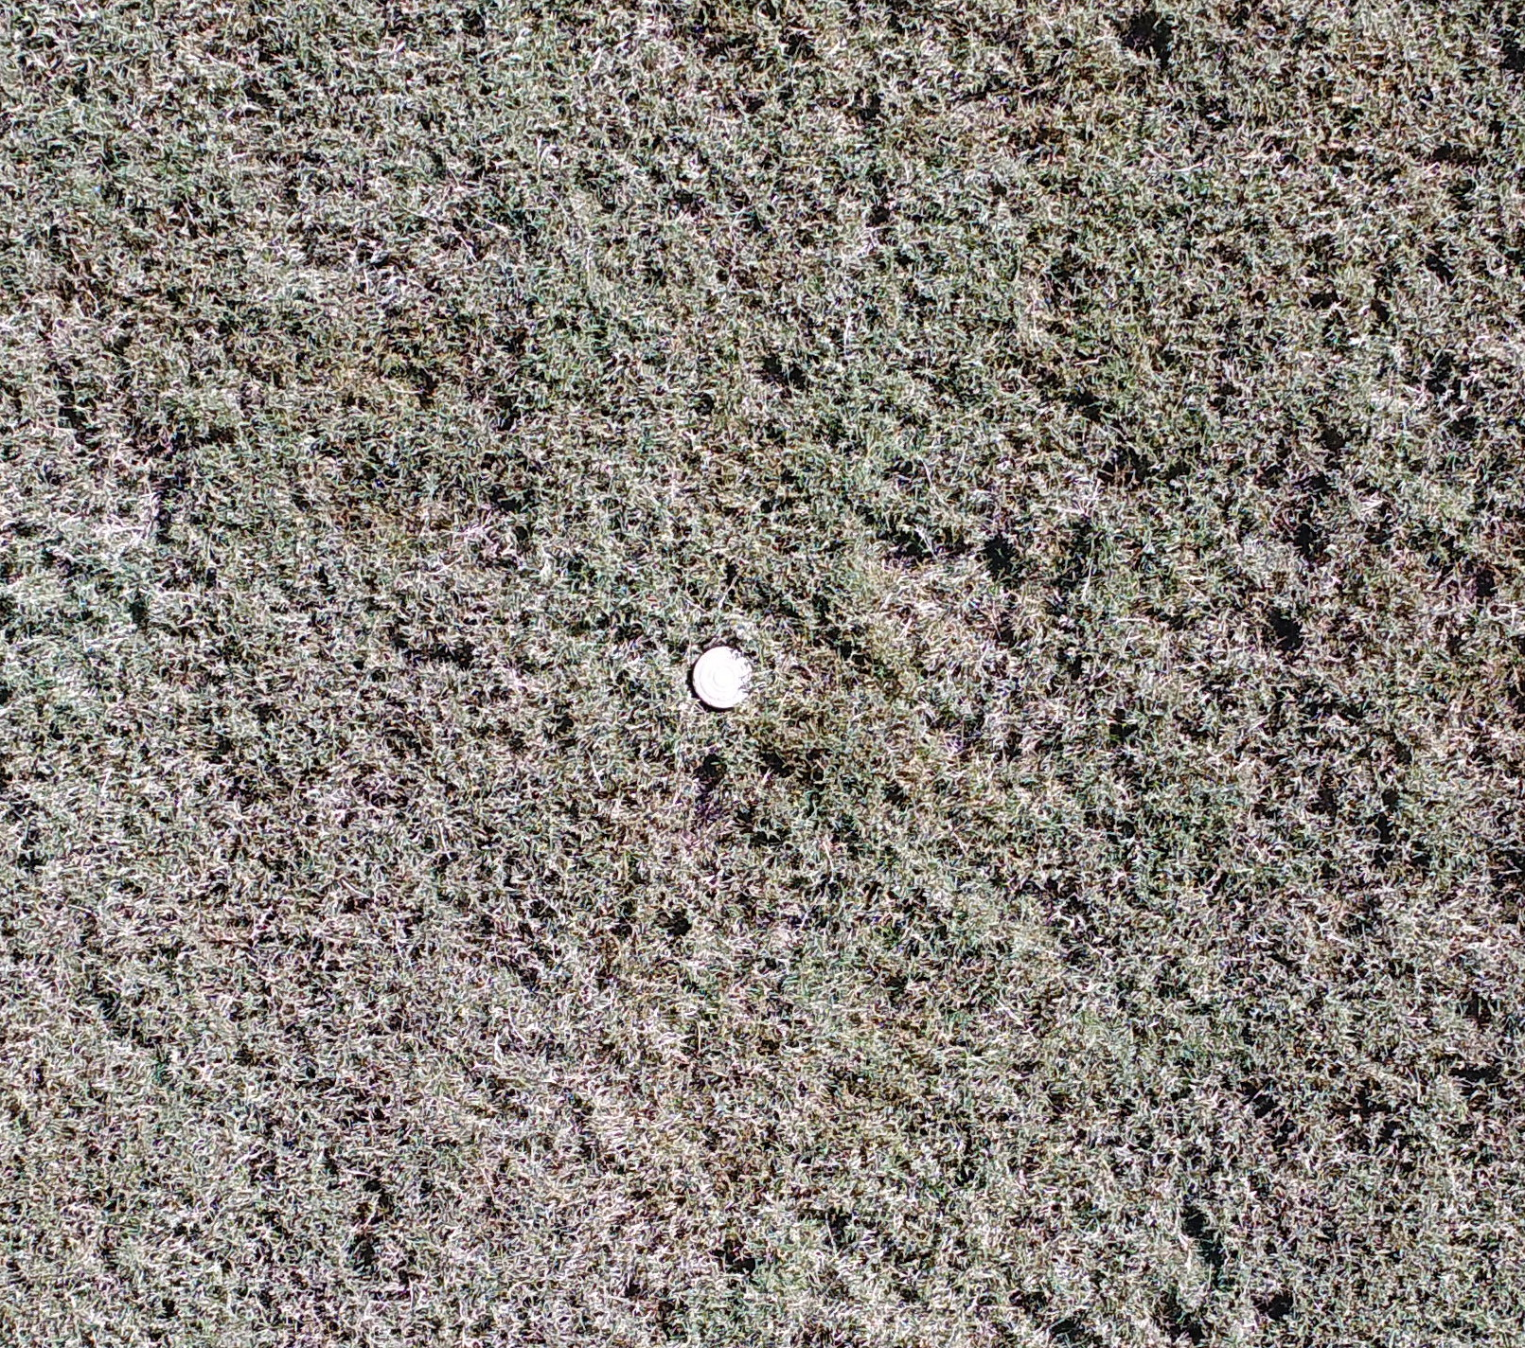
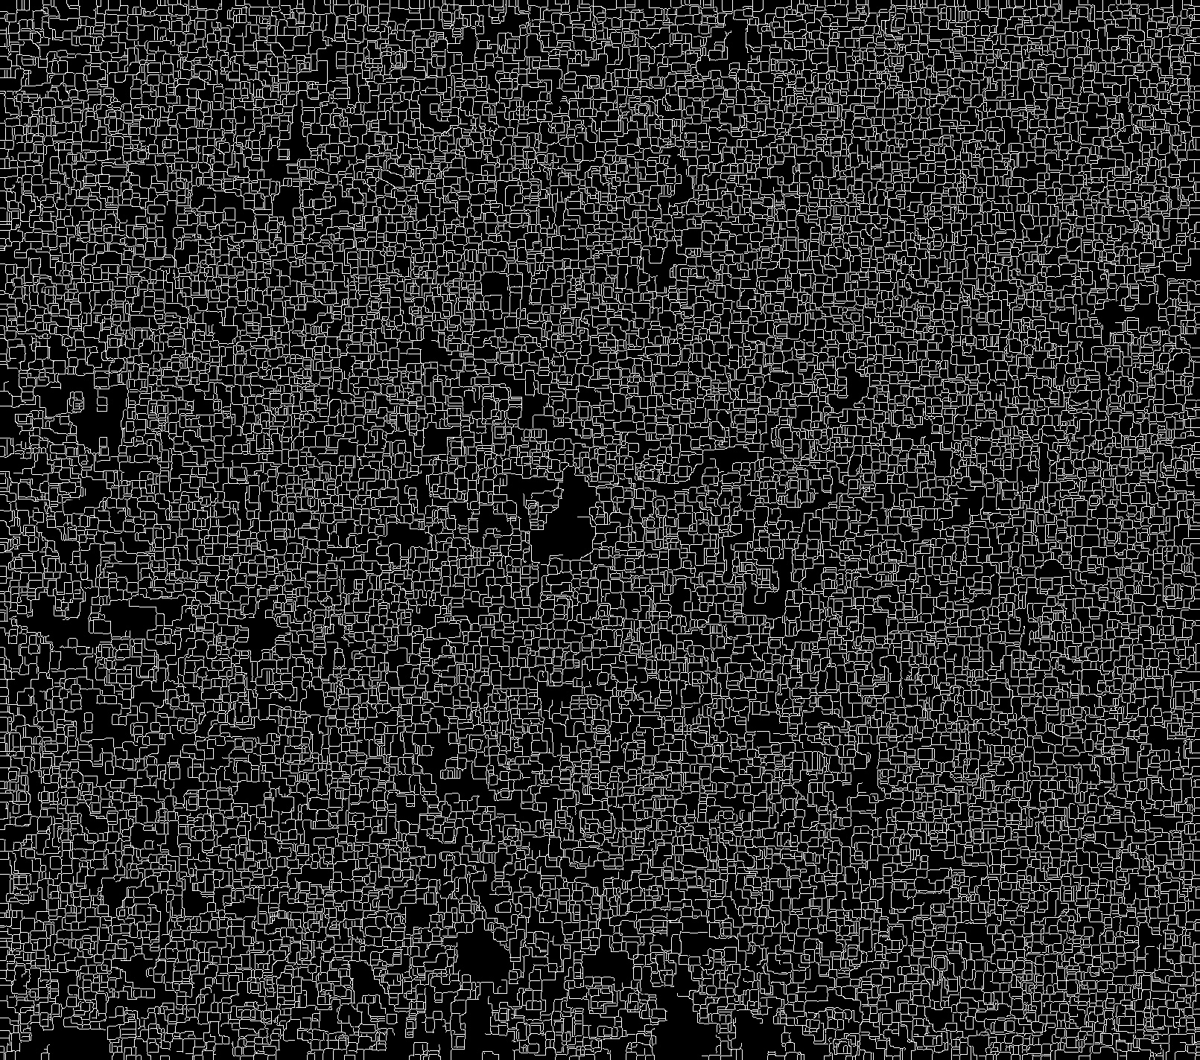
This week I have been working the possibilities of incorporating Hough transform and Canny Edge detection in to my processing. Because CV.2 only uses one band at a time I separated each of the bands then preformed a dilation and erosion to remove small noise and fill small holes created by the grass. Next I merged all of these bands a preformed an canny edge detection. The original image and the results can be seen below.

As you can see the Canny edge detector is still picking up on a lot of noise and from the grass and not creating good edges for the hough detector to run efficiently.

I attempted to use simple RGB vegetation indices like the visible atmospherically resistant index (VARI) however the index did not do a good job of discriminating between the mine and grass.

The rest of the week I have been preparing my 2 study sites which will contain 20 mines each I will be collecting 5 band data. This should be a big step forward with this project because it will allow me to preform highly accurate vegetation and soil indices. I anticipated that removing pixels deemed to be vegation will leave behind a blob of mine pixels that I can leverage with canny and hough transform.

My project data can be found here. https://github.com/drewk1992/Mine

